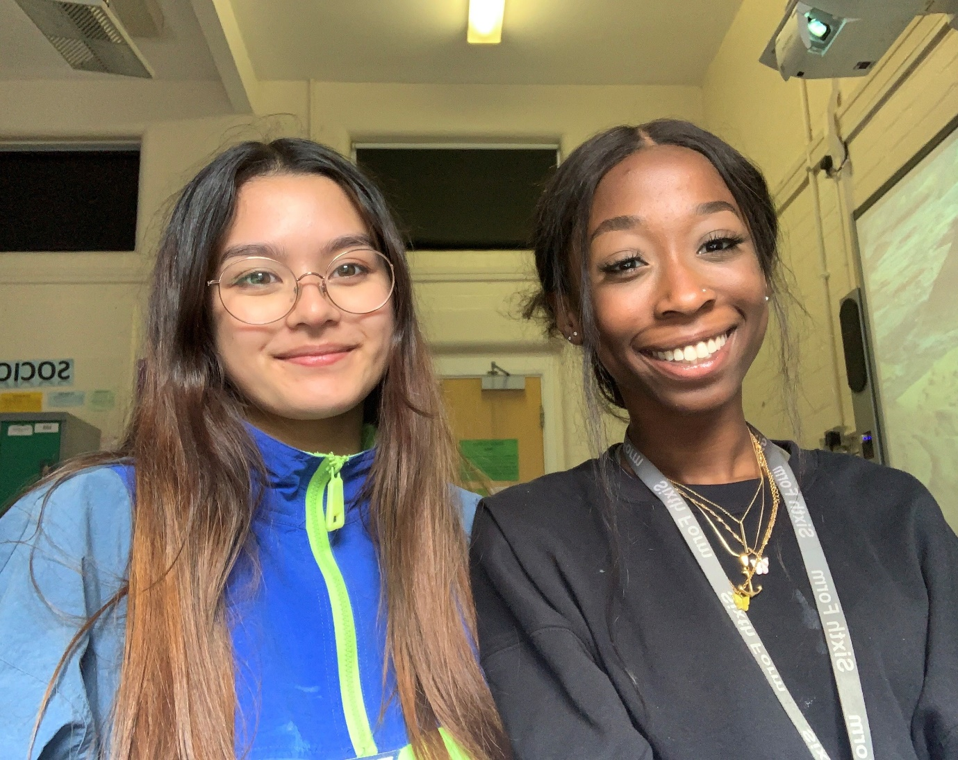
We are so honoured to be Student Leaders because we are able to lead such a vibrant and welcoming community, inspire students to reach their full potential, and make a difference in the Kendrick student life!

Angelica & Letitia 2020

